Course: INFO-6103 – Enterprise Application Modelling
Assignment: Assignment #2 – Web Services Application
Title: News, Weather & Currency Dashboard with Customer Name Storage
Group Members:
- Modha, Namrata Sharad – 1214320
- Quimod, Brian – 1181301
- Salama-Eid, Cristine Grace – 1200707
- Brito, Jay-R – 1165408
- Philip Ukodei - 1179910
- Ardayfio, Harold Nii Oblie – 1204963
Submitted to: Prof. Christina Lederman
Date: March 26, 2025
Open Exchange Rates
https://openexchangerates.org/
username: namsm
mail: modha.s.namrata@gmail.com
password: OpenExchangeRate
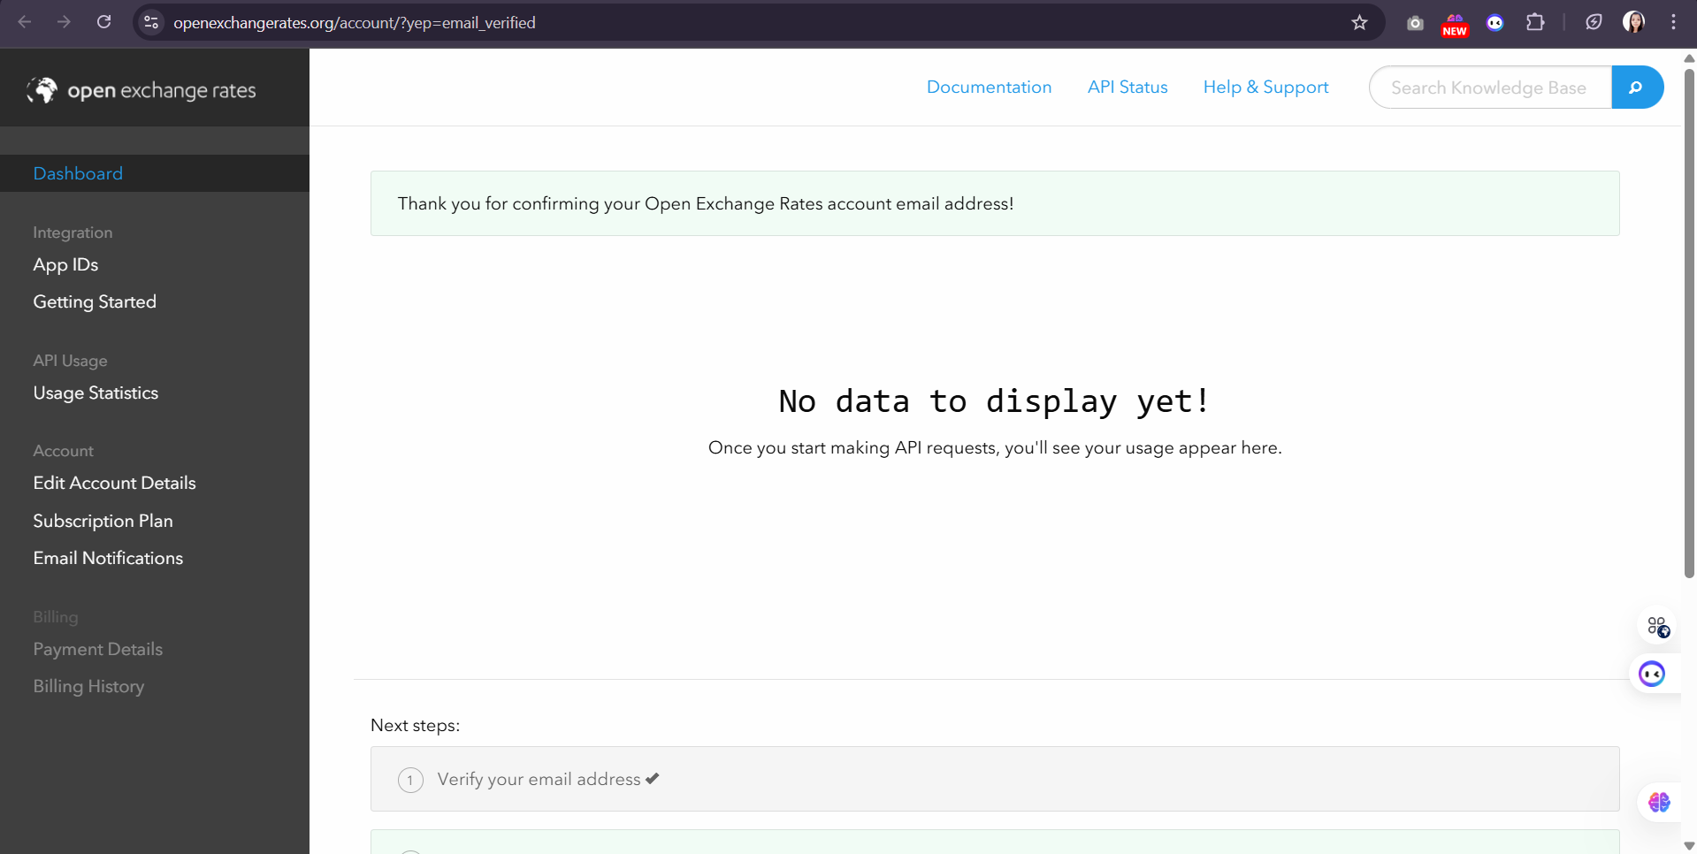
Open Weather API
https://home.openweathermap.org/
username: namsm
mail: modha.s.namrata@gmail.com
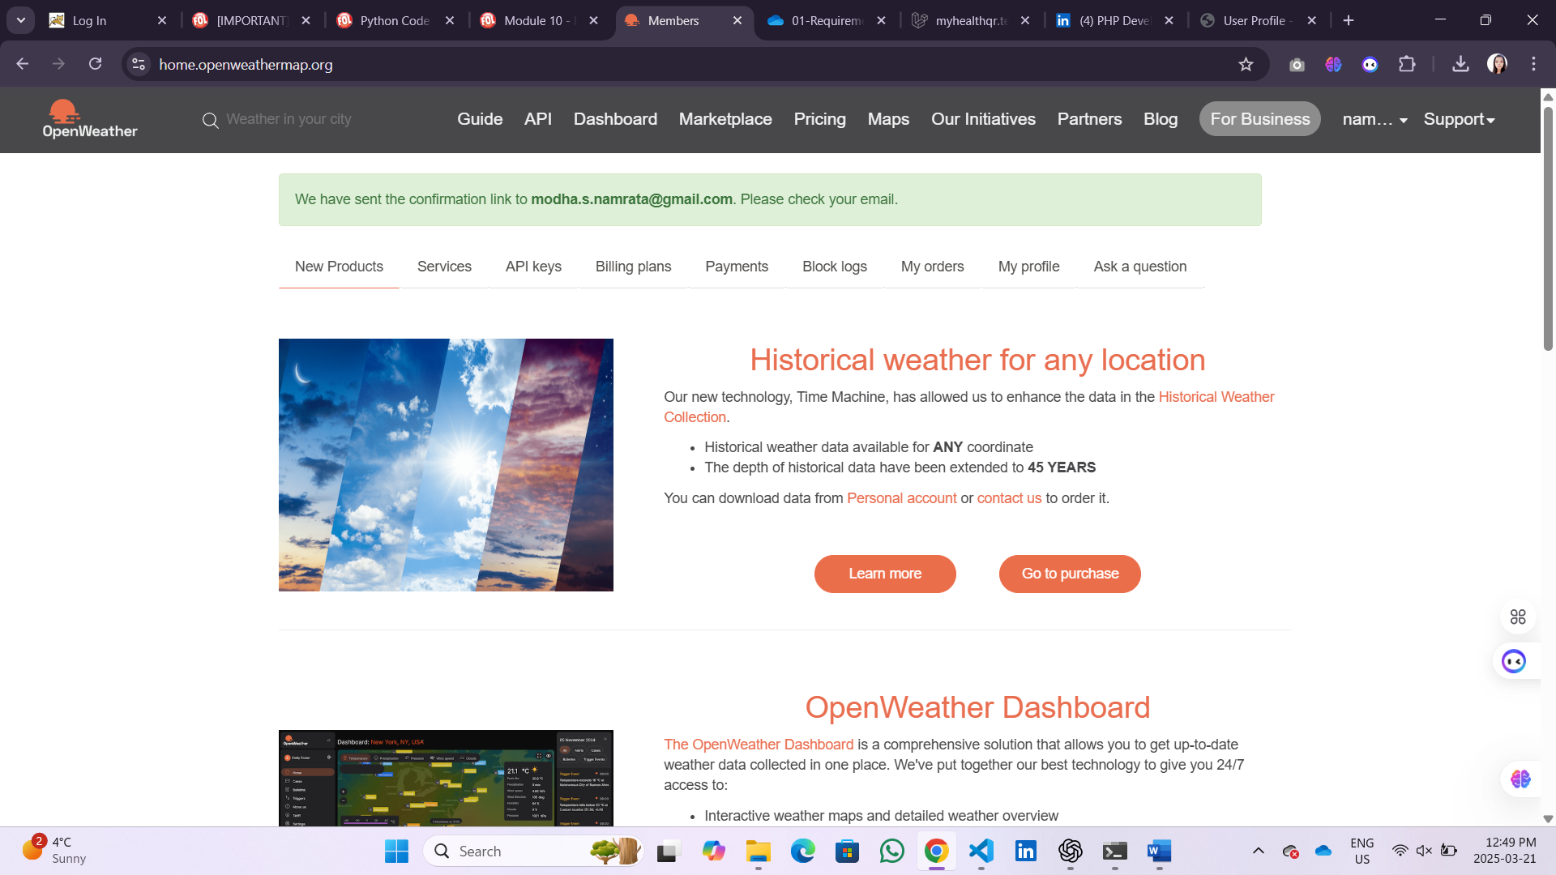
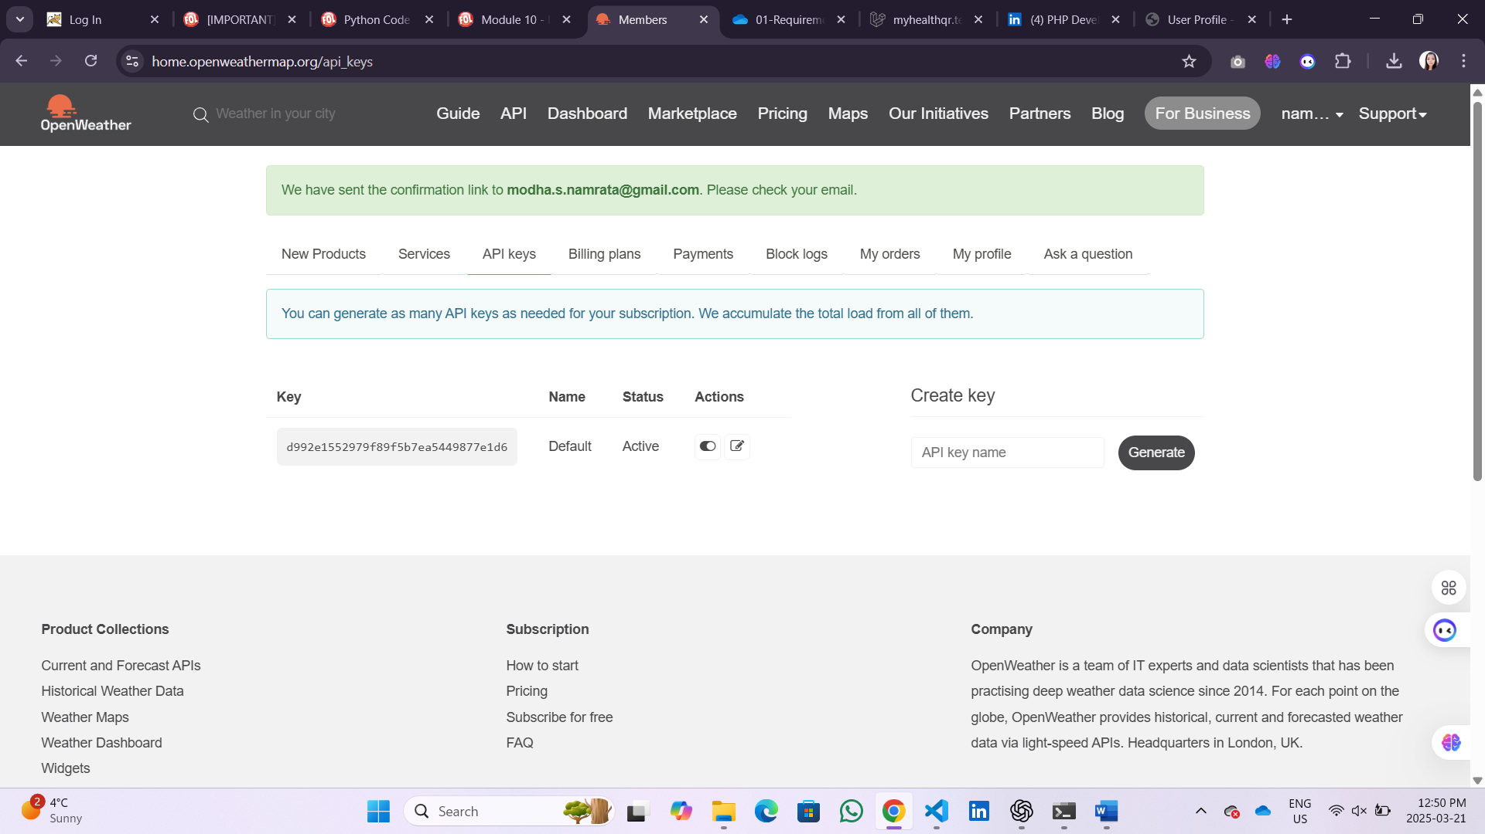
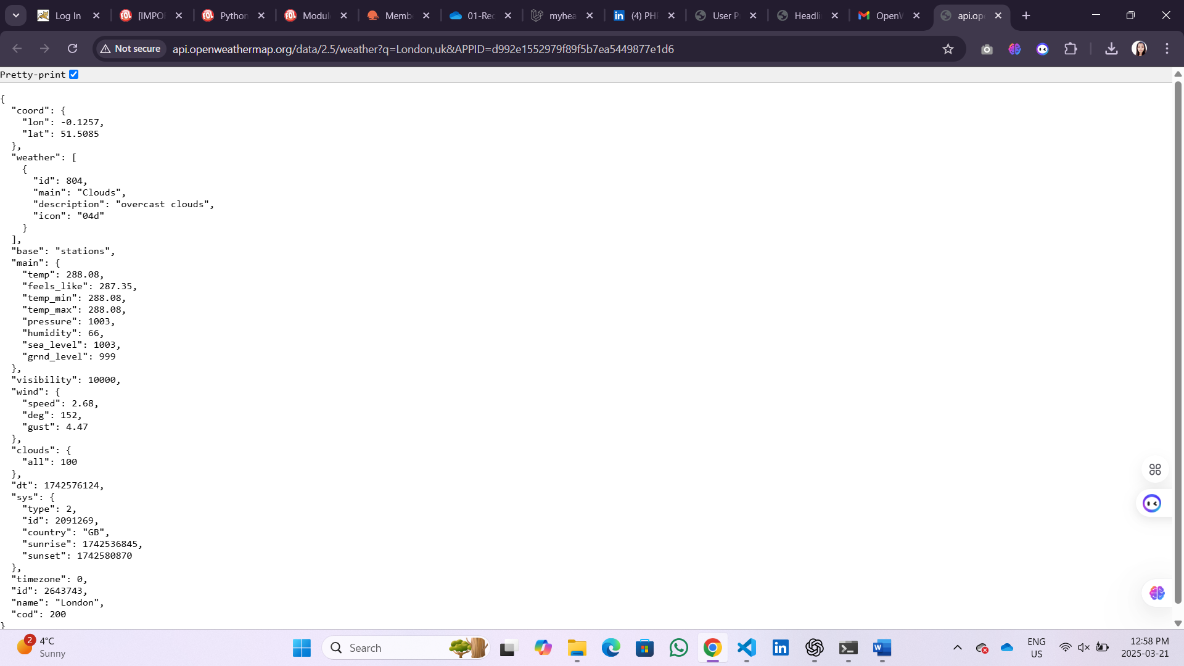

Creating Database
Step 1: Open VS Code
- Open VS Code
- Go to File > Open Folder
- Navigate to the path above and open the Assignment 2 folder.
Step 2: Create Files
Create 3 python files new files:
- dbconfig.py
python
CopyEdit
# dbconfig.py
DATABASE_PATH = 'customer_data.db'
- dbhelper.py
python
CopyEdit
# dbhelper.py

import sqlite3
from dbconfig import DATABASE_PATH

def init_db():
with sqlite3.connect(DATABASE_PATH) as conn:
cursor = conn.cursor()
cursor.execute('''
CREATE TABLE IF NOT EXISTS customers (
id INTEGER PRIMARY KEY AUTOINCREMENT,
name TEXT NOT NULL
)
''')
conn.commit()

def insert_customer(name):
with sqlite3.connect(DATABASE_PATH) as conn:
cursor = conn.cursor()
cursor.execute('INSERT INTO customers (name) VALUES (?)', (name,))
conn.commit()

def clear_customers():
with sqlite3.connect(DATABASE_PATH) as conn:
cursor = conn.cursor()
cursor.execute('DELETE FROM customers')
conn.commit()

def get_all_customers():
with sqlite3.connect(DATABASE_PATH) as conn:
cursor = conn.cursor()
cursor.execute('SELECT * FROM customers')
return cursor.fetchall()
- init_db.py (to create the table just once)
python
CopyEdit
# init_db.py
from dbhelper import init_db

init_db()
print("Database initialized.")
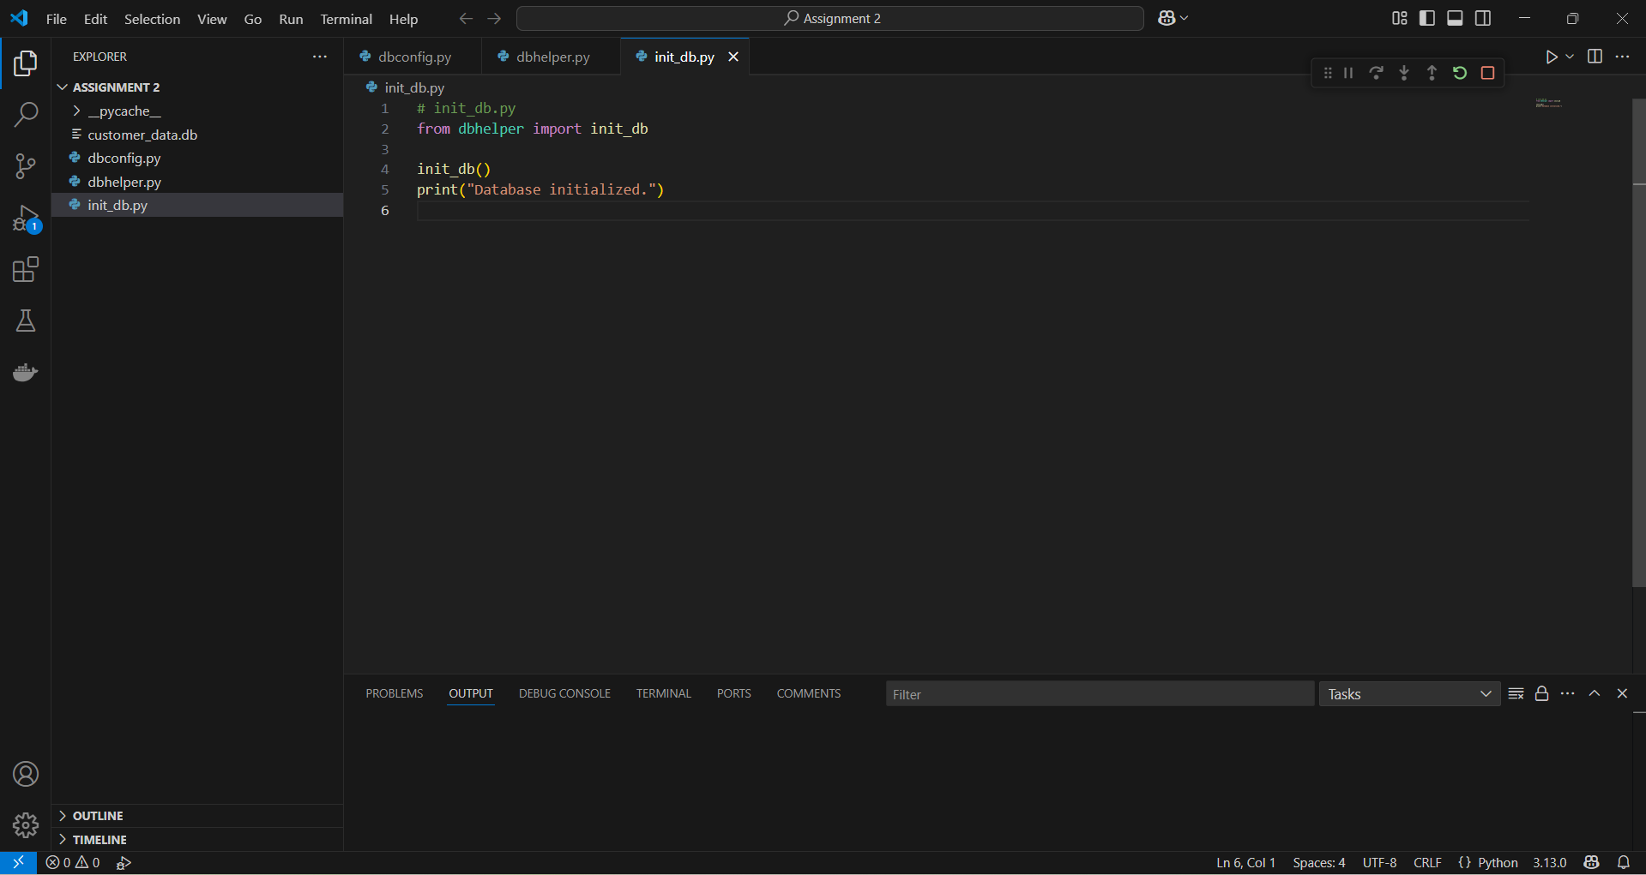
Step 3: Create app.py python file in VS
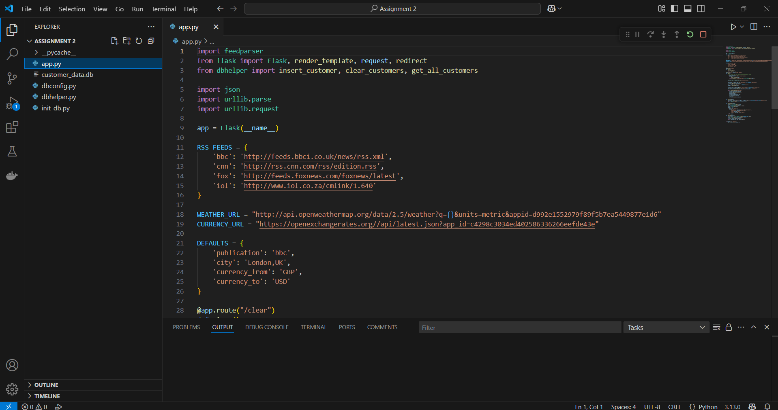
Step 4: Create templates folder.
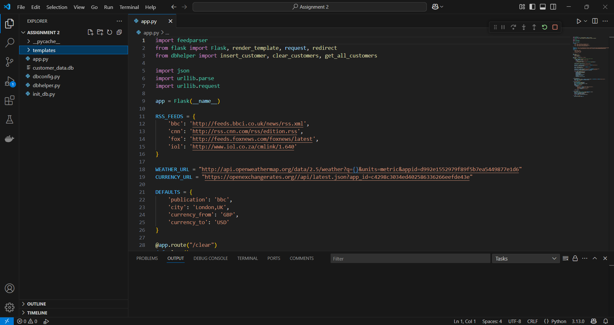
Step 5: Create home.html in templates folder.

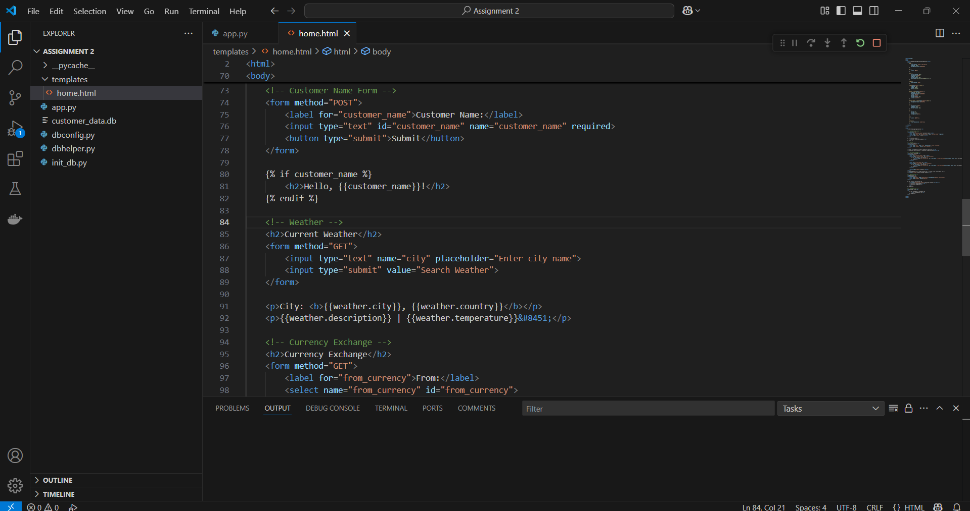

Screenshot 1: Default View
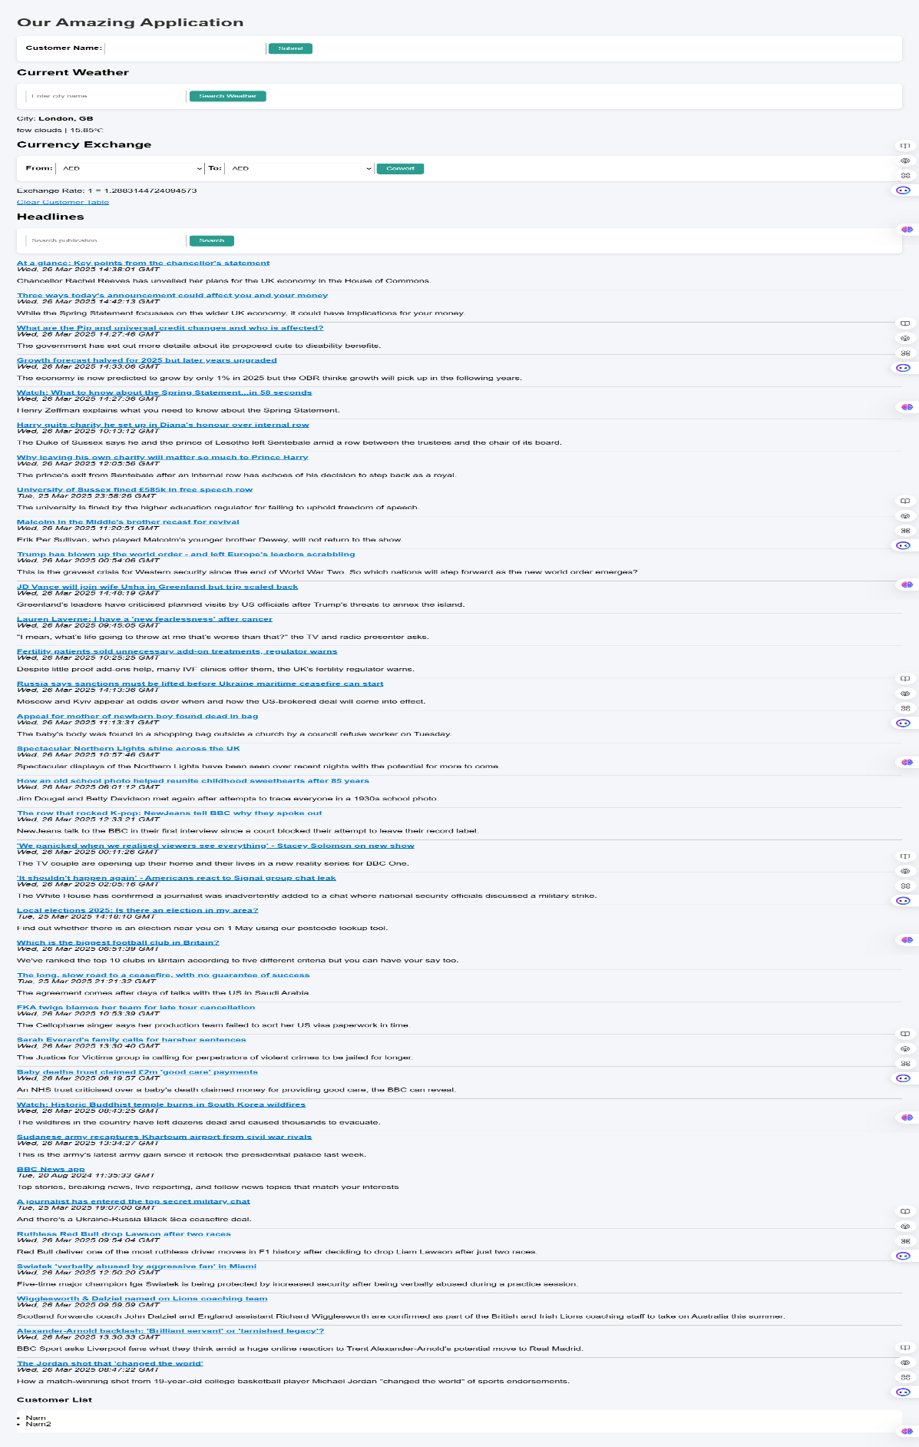
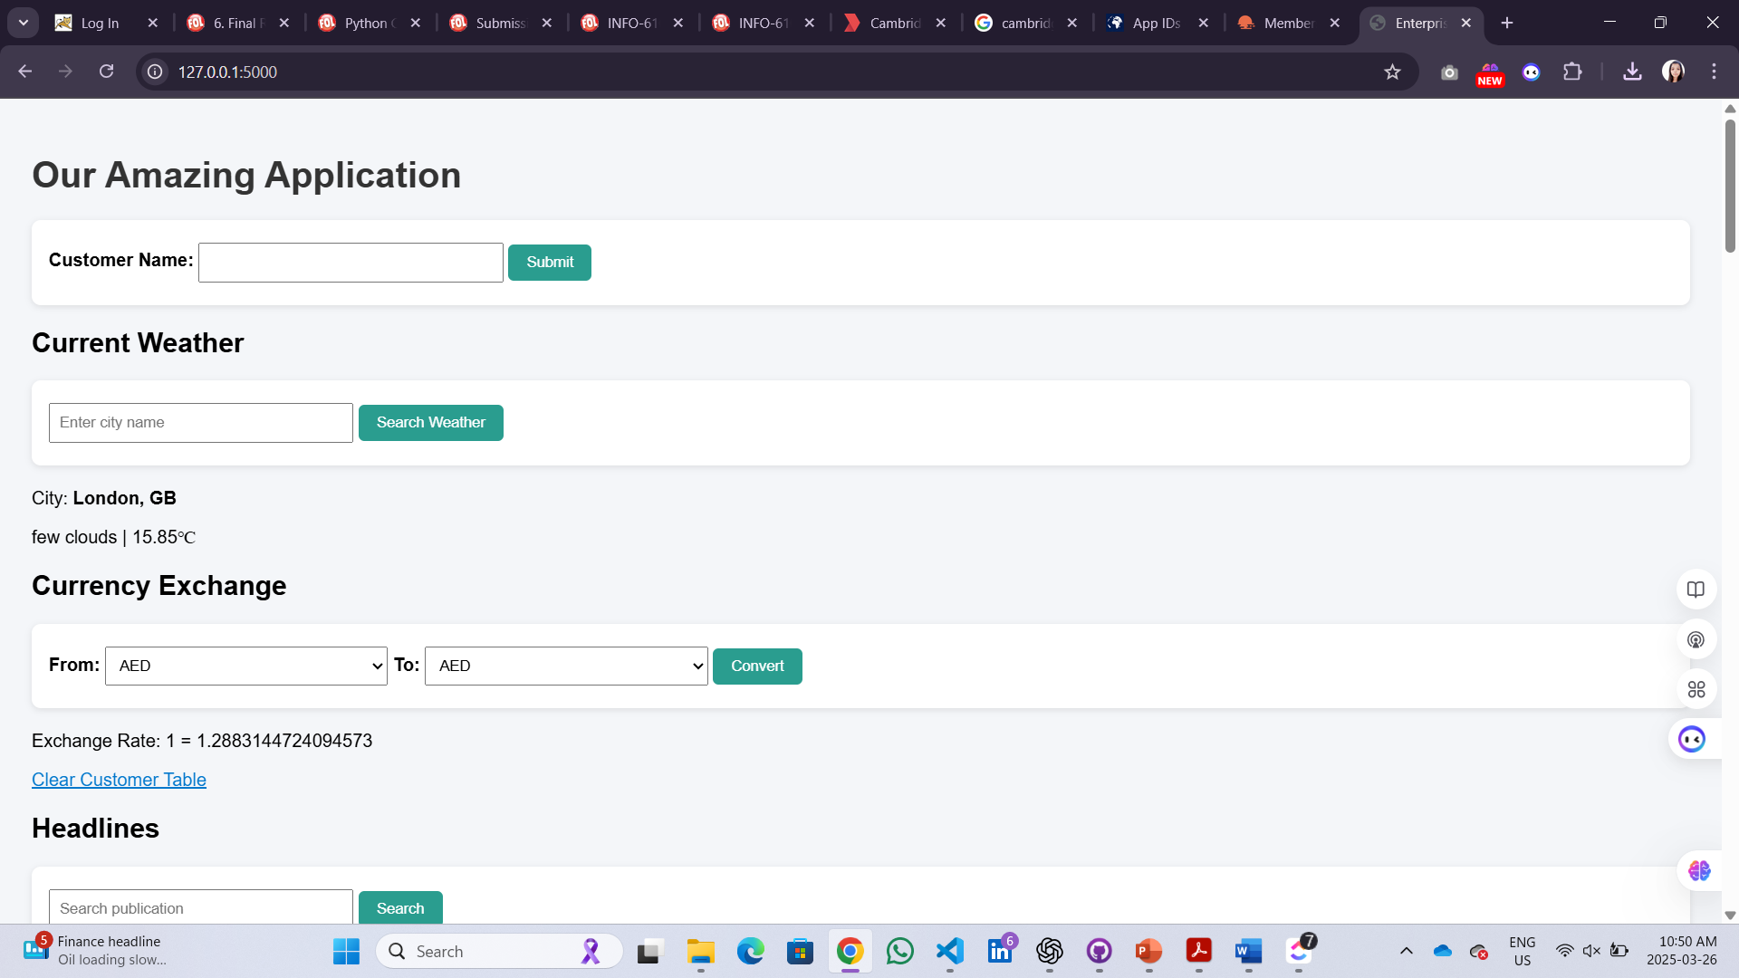
Screenshot 2: After customer submit:
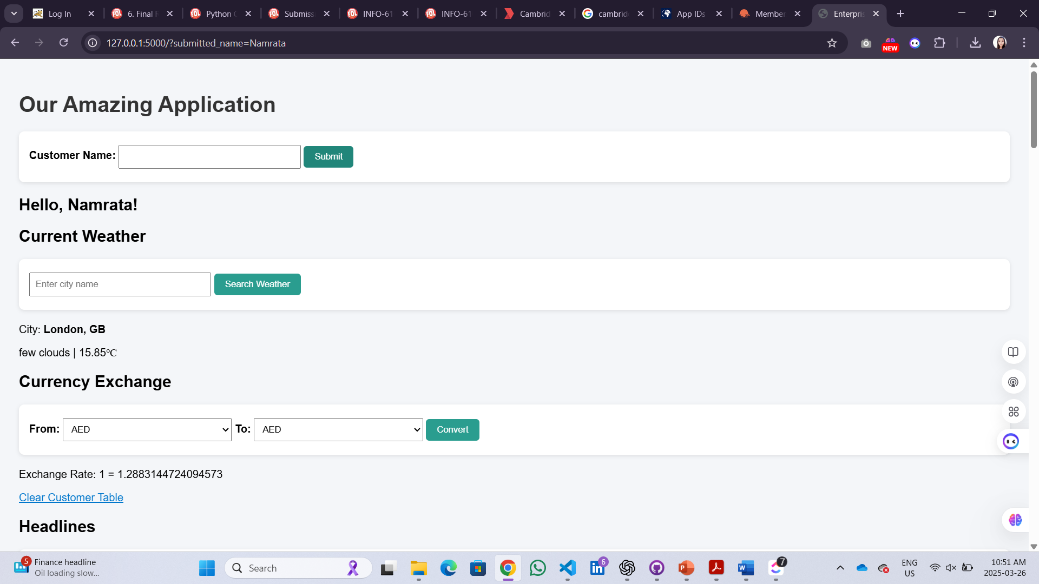

Screenshot 3: Customer List updated
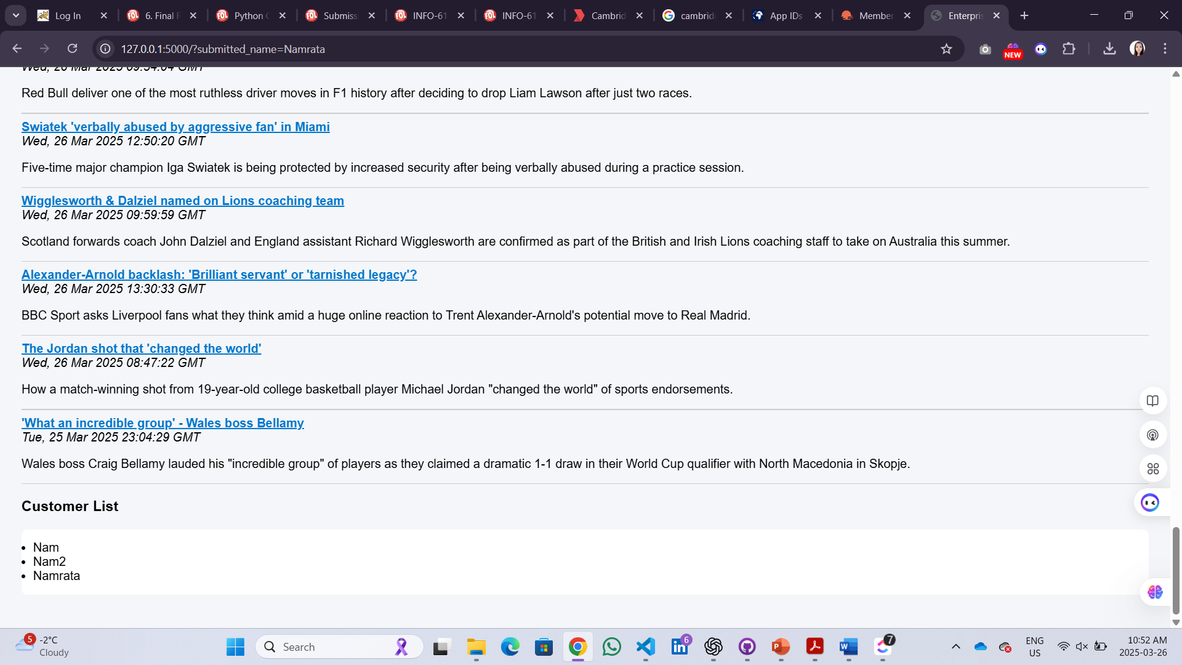
Screenshot 4: Weather search example:
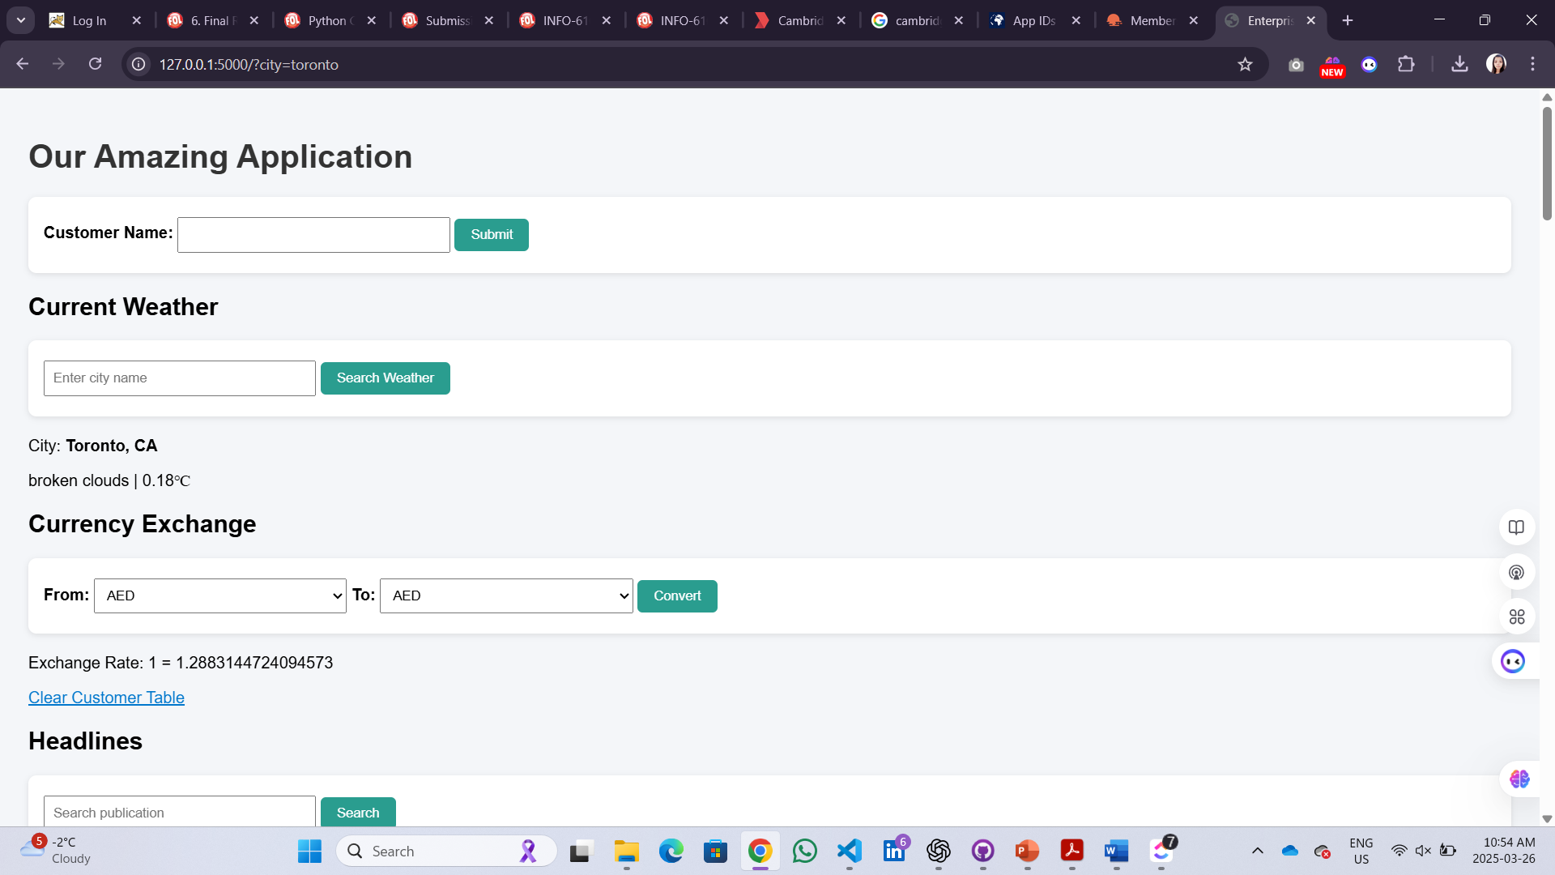

Screenshot 5: currency conversion
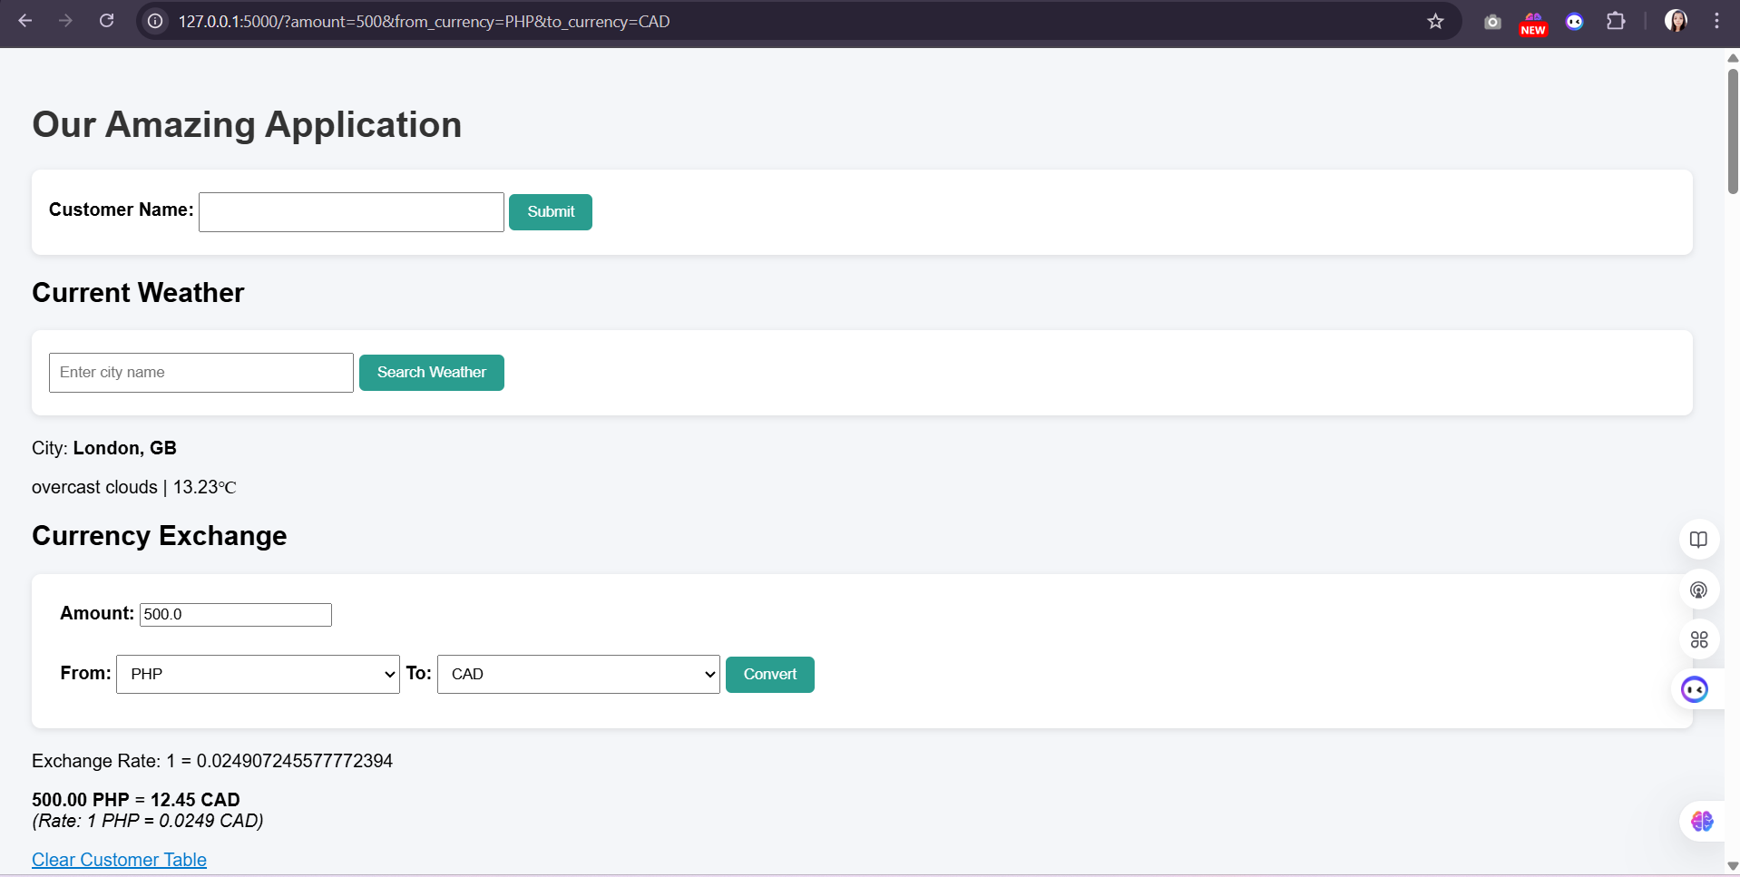
Screenshot 6: Clear Customer
